VideoQuery: Content based Video Retrieval

Ratin Kumar  
Department of Computer Engineering  
National Institute of Technology, Kurukshetra  
ratin_11822004@nitkkr.ac.in

# **Abstract**

Digital media, comprised largely of images and videos, has been on the rise in the past decade. Due to its ease of access and efficiency in spreading information, Pixels now have become the currency used by most information transaction on the Internet.

We present VideoQuery. a object detection based deep learning framework which leverages the scenes from video clips to generate set of fixed sized vectors for videos. These fixed sized vectors are used to video retrieval using query video clips. It offers an efficient solution which balances the precision/accuracy with processing computation.

(research more here, for simiar models)

To validate our approach in a “wild” environment, we also test our algorithm on two datasets, MovieClips dataset. We also show the benefits of using our proposed framework in a more constraint environment where the objects occuring in the frames are already known. On UFC101, generates competitive performance in terms of run-time and accuracy. Code is available at: https://github.com//dumbmachine/videoquery

**Keywords**: Content-based video retrieval, Video Database, object detection, approximate nearest neighbour search.

# **Introduction**

Video search is a very challenging problem which not only requires alot of processing but storage as well. Internet has seen the sites like Google Images and Tineye which provide the facility to reverse image search, but such facilities for reverse searching videos using small clips or even images are yet to see the sunshine. Large amount of information is stored in video files as multiple image frames. Thousands of hours of video data are uploaded to the internet every minute !(I think that the previous line can be phrased better).

The problem of video retrieval using media can be divided into two smaller tasks; conversion of video into fixed sized vectors and searching for simlarity between the query clips and the clips in the database.

Recently, deep CNN has been successfully applied on many vision tasks, such as image classification (Krizhevsky, Sutskever, and Hinton 2012) and image segmentation (Sharma, Tuzel, and Jacobs 2015), which shows the powerful ability of deep CNN for describing complex non-linear mappings and learning rich mid-level representations. The CNN features learned from data are discriminative, but still high dimensional for the retrieval task. . In retrieval tasks, the hashing-based methods which project high dimensional features to a low dimensional space are often used (Liu et al. 2012; Li et al. 2015b), but feature extraction and hash

function learning in these methods are independent, in other words, the extracted features may not be compatible with the hash coding process. Some models use an end-to-end system for mixing the feature generation and its appropriate hash generation (Dong, Jia, Wu and Pei 2016).

Many algorithms exist for exact video retrieval (Large-Scale Video Hashing via Structure Learning) (Robust Video Hashing via Multilinear Subspace Projections) which take a route very similar to that are used by image retrieval, wherein the a hash is generated for each video in the database. Then hamming distance is used as the measure of similarity between the hashes.

However, most current works in scalable visual search focus on image-based retrieval [6]–[14] or text-image/image-text retrieval [15]–[19]. To our best knowledge, no frameworks exist which provide a video-video retrieval.

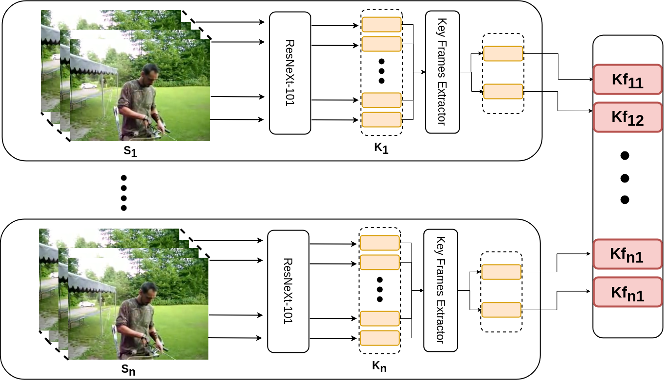**Fig. 1**. Illustration of the proposed framework for converting video into a fixed sized vector. The input video clip in divided into segments, each of size equal to its frames per second equivalent. Each segment is fed into an object detector. Frame features obtained object detector are fed into the clustering algorithm which returns the features from the most distinct frames.

We present a novel scalable solution for Content Based Video Retrieval, which uses the object location information of the video frames to extract key frames from the videos and generate fixed sized vector representation of video clips to allow to fast and efficient searching.

An object detection model is used to obtain inference of each frame. The inference information is used to cluster the individual frames obtaining key frame representations of each scene of video. We define a "scene" as set of frames in video wherein the total change in information, prominently the objects, their location and background , is minimal. This helps use to remove redundant frames while making sure unique frame informations are not lost.

Our proposed solution is highly scalable, the inference of video frames can easily be run on multiple gpus and the algorithm used for clustering of video frames is also highly parallelized. This system makes use of the resources available to it efficiently. Bucket-like searching using approximate nearest neighbour search allows the framework to search fast.

# **Related Works**

In this section, we briefly review realted topics: 1) feature comparison based searching 2) video hashing.+

categorize the papers and give example and reference for each one of them`

# **Proposed Approach**

In this section, we formulate the proposed DeepQuery framework (Fig. 1). Notations and problem

definition that will be used in the rest of the paper will be

introduced first. Then we will present two major components of our novel framework, Key Frame Extraction and Bucket-like approximate nearest neighbor search.

## Notation and Problem Definition

Given a video **V** = {**s**1, **s**2, … **s**n} ∈ R having **Fr** number of frames and its fps as **Fp**, where **s**i refers to the **i**th segment of the video, and **n** is the number of segment with **n** = **Fr** / **Fp**.

Each frames in segment **s**i in **V, s**k  = {**f**1k, **f**2k, … **f**mk} with 1<m<**Fp**, are denoted by **f**jk, where **j** is the index of the frame in the segment and **k** is the index of the segment in the video **V**. Each frame **f**jk comprises of objects that can be identified by the object detector used : **f**jk = {**o**1k, **o**2k, … **o**mk} !(objects information needs a check here). N denotes the number of videos in the dataset. **T**h is the number of frames to be extracted from each segment of the video.

## Object Detection

Will talk about the choice of object detection here. The importance of using a very accurate Object detection algorithm. Ending with a note that using a highly specialized object detector to only detect a few classes will reduce the scope of the framework but will make the accuracy of this framework go through the roof.

(A pre-initialized state-of-the-art convolutional neural network (ResNet-101) is usedto extract semantic information from the image frames to construct features that represent the content of the image.We call

this vector V (x i ).

V (x i ) = CN N (x i ) …. (1)

where i ∈ {1, . . . N } is one of the images in

the dataset of N images.)

(B) Mention details of the features obtained from the object detector.

(C( Mentioned the use of minimum confidence when detecting the objects, its to reduce the shit (side makes it look at low confidence as something else)

(D) Mention the shape of the feature obtained from the object detector

Alot of work has been done in the field of Object Detection. Current State of the Art methods of Object Detector employ novel techniques like using composite connectection between identical backbones of the object detector (CBNet), processing region of images instead of each pixel (SNIPER) or using completely anchor-free framework which produces results by predicting category-sensitive semantic maps and bounding boxes (FoveaBox). While the accuracy of these novel methods are very high, they suffer from the drawback of requiring alot of resources to process the images rendering them useless for this task of Video Retreival where the video databases are built after processing millions of frames from the videos. Slow inference will also hinder the ability of this framework to be used as a real time system.

Thus for the apt object detector, it should have a balance of accuracy and processing speed. SSD Mobilenet [reference here] was chosen as the object detector. The requirements and resources available at the time of writing this paper made it the best choice for the Object Detector. The detector was pretrained on the COCO dataset (Lin, Tsung-Yi et al. “Microsoft COCO: Common Objects in Context.” ArXiv abs/1405.0312 (2014)).

The objective of the using the object detector in this framework is to obtain a vector representation of each frame. The following information is noted for each object in the video frame: Category of the detection, Confidence Score of prediction, bbox coordinates of the object. Depeding upon the number of objects detected in the video frame the shape of the vector Vd will belong to the set {6, 12, 18, ... }. These vectors obtained from each frame are used as the features for key frame extraction from each segment of the video. The shape of these vectors being in multiple of 6 are taken advantage of in during video retrieval, more details are explained in the searching section.

As an extension to the current framework we will also show (in test2) that making use of fine-tuned object detectors, on the categories of objects involved in the video database, increases the accuracy of the video retrievals. For this purpose the object detector were trained on the DATASETNAME, which included the objected from the MovieClips dataset.

Consider a video clip V, the output of the detector for each segmentis denoted as :

R(**s**k) = DETECTOR(**s**k) … (1)

where i ∈ {1, . . . , N } represents the segments of the video clip V. V will be represented by the collection of its segment vectors:

R(**V**) = {R(**s**1), …, R(**s**k)} … (2)

where k ∈ {1, . . . , n} represents the segments of the video clip V.

## Key Frame Extraction

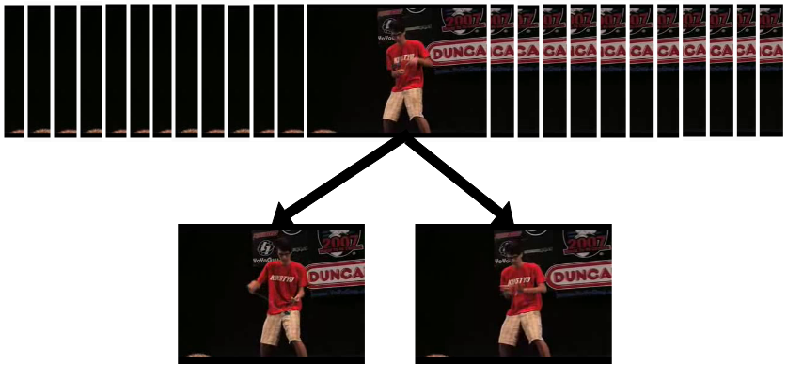**Fig. 2**. Key frames are obtained from the video frames in segments after removing all the redundant video frames. The number of key frames obtained are decided by the threshold Th.

Once object location information is obtained from the object detector, the next step is to extract the key frames to get rid of the redundant frames allowing for faster searching and lower memory footprint. Lets consider the object location information from the first segment of the video **s**1. Segment has frames: **S**1 = {f1, f1 … fFp} with each frame fi having its detected objects: fi = {O1, O1 … Ox} where 0≤x≤∞.

To cluster the video frames, frames are assigned to a bucket **b**iwhere 6≤i≤Om and Om is the maximum number of objects observed from a video frame. Once each bucket bi

has been assigned the buckets, the buckets are clustered using k-means clustering (reference from the sklearn user guide of k-means clustering algorithm). After clustering each frame is assigned

-------------------------------------------------------------------------

Algorithm 1 GetKeyFrames

-------------------------------------------------------------------------

!(segment as a function of frames and their respective object detections)

**Input: S(f,o), Th**, **Om**

**Ouput: {f1, … , fz}** 0≤x≤**Th**

1. B = {[]i for i ∈ {1, Om}}

2. Co = {} // cluster of the object

3. Cf = {} // cluster for the frame (mode of the objects)

2. **for** all f ∈ S **do**

3. **for** all O ∈ f **do**

4. Bi append Oi

5. **end for**

6. **end for**

7. **for** all b ∈ B **do**

8. clusterFunction(b)

9. // forgot to show the assignment of each cluster for the objects

9. **for** all f ∈ S **do**

10. Cfi ←mode(Coi)

## Searching

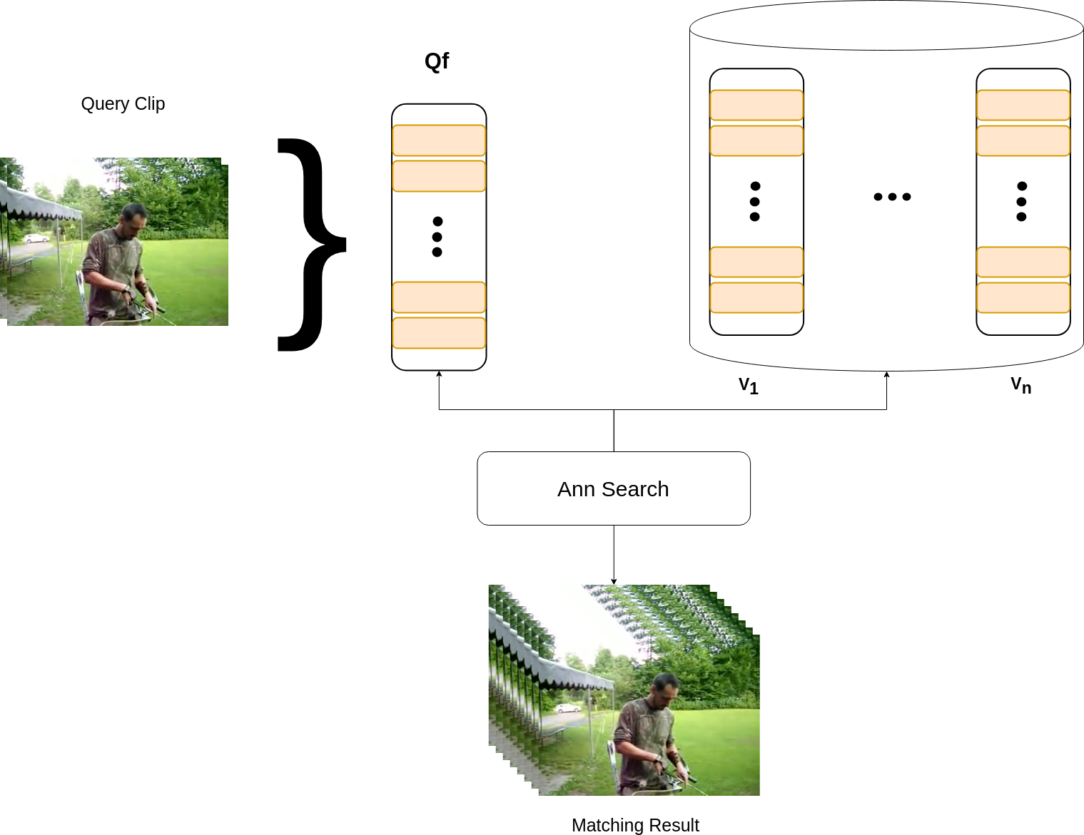

**Fig. 3**. Illustration of the proposed framework for searching query clips in the video database. Key frames obtained from the query clip are used to generate a feature vector for the query clip. Using L2 distance, as the measure of similarity, approximate nearest neighbors of the given clip are found.

The key frames of query clips are compared to the key frames from the video database and are compared using ANNG [refernce to NGTPY].

Let us consider a query clip Q and its key frame as Qfi , obtained from the prior step of Object detection and Key Frame, and respective key frame vector’s dimension be Qdi, where i is the index of key frame among all the key frames.

Extraction are employed in matching the similarity between query clips and the clips from the database. Each video v ∈ V will have Ki number of frames with

K} = Th * #S // of segments in that video

Each key frame of the video will have a dimension of Rd ,d ∈ {6, 12, 18, ...}, depending on the number of objects detected in the video frame. Each dimension belong to the set of Rd is represented as an index i. We make use of these different indexes to reduce the computation required when searching for similar video frames, this technique isolates the search to video frames with similar dimensions.

For matching query clips in the video database, each ke

# **Experiments**

**Divide the whole thing into 2 tests, 1. Simple and Normal: UCF101, 2. Awesome and Specific: MovieClips30**

**Datasets:** We evaluate our method on two datasets, a benchmark dataset UCF101 (reference here) and a custom dataset MovieClips which contains all the frames from 30 selected movies. (more details about the custom dataset can be found here, maybe link to github for more information and avoid clutter here). The first dataset, UCF101, includes total number of

101 action classes divided into five primary types. It contains 2484199 frames and the total clip lengths sum up to 26 hours. (mention the total number of key frames saved to show the sexx of this algo). The second dataset MovieClips, consists of PLACEHOLDER movies adding upto PLACEHOLDER hours. This custom dataset will show the performance of the framwork in a real-world like dataset whereas the UCF101 dataset will show the performance of the dataset on video clips constricted to few scenes per clip.

**Pretraining:** The object detector was pretrained on the COCO dataset, with details the same as the paper SSD300 Mobilenet.

## Training Details

**Network Training** The object detector was pretrained on the COCO dataset, with details the same as the paper SSD300 Mobilenet.

Show graphs of the training time and the processing time and things like that.

**Metrics**: In our experimental study, mean average precision (mAP) is adopted as the evaluation metric. The metric has been widely used in literature [23], [19] (<https://ieeexplore.ieee.org/stamp/stamp.jsp> [tp=&arnumber=7464865](https://ieeexplore.ieee.org/stamp/stamp.jsp?tp=&arnumber=7464865)). For a given query, average precision (AP) is calculated as

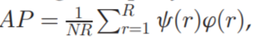

where R is the total number of retrieved videos, NR is the number of relevant videos in retrieved set, cðrÞ denotes the precision of top r retrieval videos, which is defined as the ratio between the number of the relevant videos and the number of retrieved videos r, and ’ðrÞ is indicator function which equals to 1 if the rth videos is relevant to query, and vice versa. mAP is defined as the average of the AP of all queries. Larger mAP means the retrieval performance is better. In experiments, we set R as 100 to collect results. Furthermore, Precision-Scope curve is also reported to reflect the retrieval performance variations with respect to the number of retrieved videos.

## Implementation Details:

In this section, we will introduce implementation details of our model. For each video, **Th** the number of key frames extracted from each segment was chosen as 5. This number was chosen considering the average number of frames (write the average number frames here) .

## Evaluations and Settings

We follow the evaluation protocols used in [21] and adopt the following two criteria: (1) Hamming ranking: All the video clips are ranked according to their Hamming distance to the query video. (2) Hash lookup: A hash lookup table is constructed and all the samples fall within a Hamming ball with radius r (r = 2 in our setting) to the query sample are returned. Since each query video is represented as a set of binary codes corresponding to the frames in the video, here we adopt the following query strategy to return the nearest neighbor (NN) video clips. For Hamming ranking based evaluation, it is fairly straightforward to return the nearest video clips by exhaustively computing and ranking the video Hamming distance between the query and the database samples, as defined in Eq. (3). For hash lookup based evaluation, we first retrieve the nearest neighbor frames within Hamming radius 2 for each individual hash code vector of the query video frames. Then all the videos whose composite frames are successfully hit by any query frame will be regarded as the candidate NN videos. An intuitive way to rank all these candidate NN videos is by counting the hit frequency of each video (normalized by the number of total frames in that video). Note that these two evaluations focus on different aspects of hashing techniques.

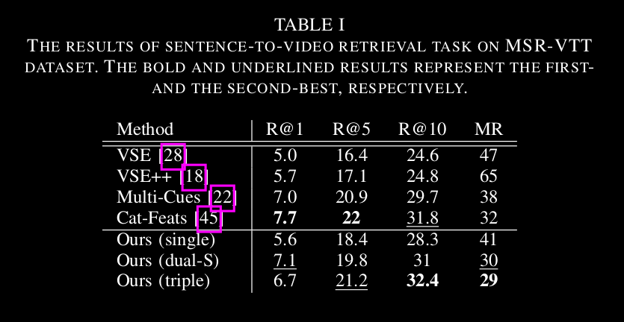

# Results

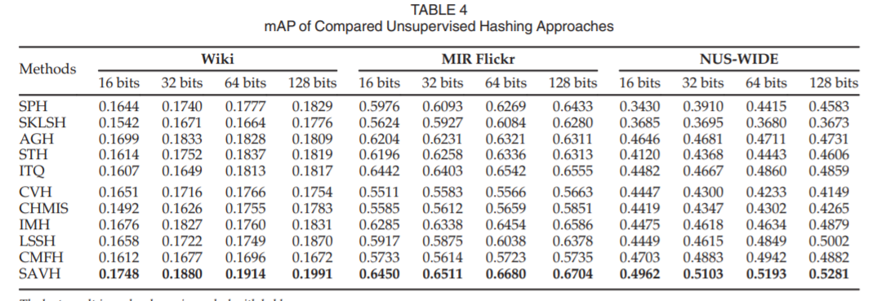

Showing the METRICS for each of the dataset.

Table ^ shows the results we get when using frame vectors of shape as a multiple of 6. The reasoning for the low precision can be attributed to the fact the framework searches for frames with similar object configuration. This gives rise to cases like the one visualized below. The framework successfully returns frames with similar object configuration but they are totally different frames.

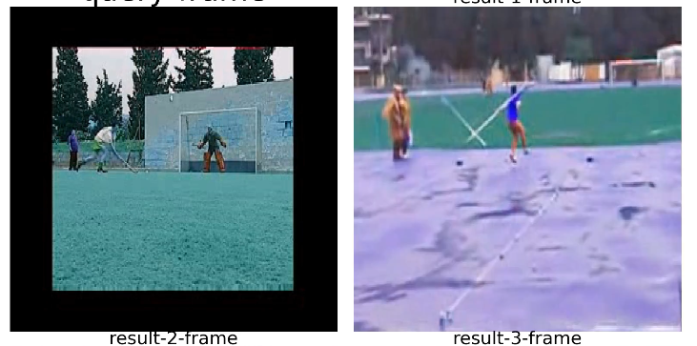

(add a query frame here)

This can be tackled by simply adding some indicator about the colors and background of the frames vector. Low dimensional histogram, which adds the color based information of the video frame. Histograms were chosen because of their relevance as low dimensional vectors.

The test the new addition to the framework, where the frame vectors are made using object information received from the object detector and n dimensional histogram vector added together. The following are the results from using different sizes of histograms.

NOTE: The histograms are only used during the searching of the vector and not for clustering of redundant frames.

IMAGE

# Conclusion and Future Work

As seen from the PLACEHOLDER, the performance of the proposed framework makes it viable for real-world usage. It is interesting that simple object location and histogram combined as a vector, are enough to retrieval video frames in huge databases like the ones used here.

In future we would like to explore the use of more powerful object detectors and Neural Network extracted features inplace of histogram features. This should increase the accuracy of the framework, while increasing the total processing time for each video clip. We would also like to test and evaluate other algorithm for searching of similar video frames.

**References**